# Basic plot outline:

**1. Introduction**

- Introduce protagonist – a 17 year old girl ,

- Establish the setting i. e. the world you are putting your protagonist in – cyberpunkworld year 2225 , where people interact in a **meta vr** world and they avoid the real world called the **meatspace**

**Metaverse company name -**

**2. Inciting Incident**

- she discovers a glitch while playing a **game** ,

- Protagonist discovers hidden information/ receives a mysterious message/ is hired for a job (basically the mystery begins)

- This sets story's central conflict (mystery + protagonist's role) in motion

**3. Rising Action**

- Protagonist delves deeper into the mystery

- Encounters obstacles, rivals (individual villain/ organized criminals/ corrupt corporation or government)

- Finds out about conspiracies, hidden agendas, or secrets

**4. Midpoint**

- Protagonist gains crucial information or makes an important discovery

- This intensifies conflict, maybe also raises protagonist's stakes

**5. Complications and setbacks**

- Protagonist faces increased opposition, (somebody can betray or double-cross, or there might be unexpected challenges)

- This outer conflict leads to inner conflict (may be moral ambiguities, or difficult choices)

**6. Climax**

- Protagonist confronts main antagonist, corporation, or system

- Final showdown (can also include rescue if someone has been imprisoned or kidnapped)

**7. Resolution**

- Consequences of both climax and protagonist's actions

- Implications for the world (your world; the world that you have built in your story), and protagonist's future



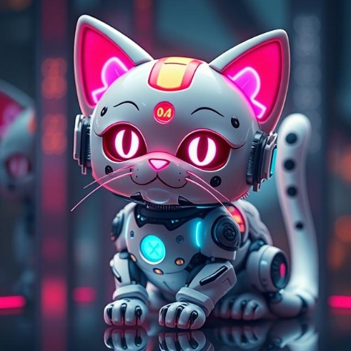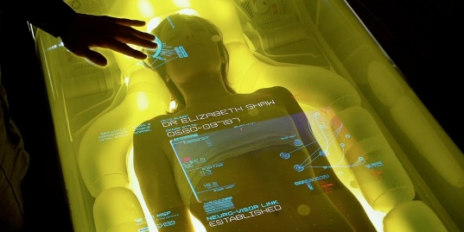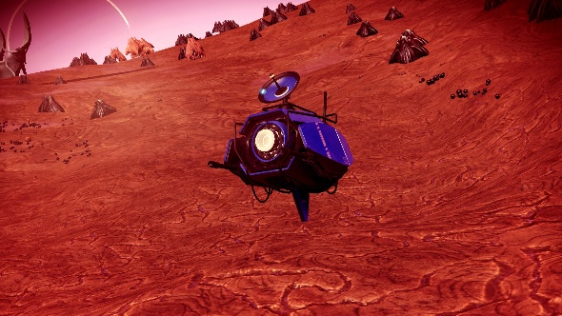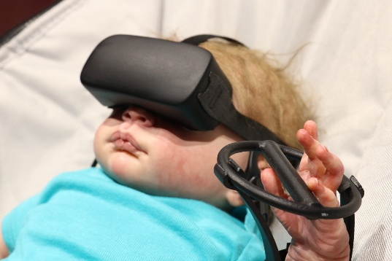-# Okay this might look complicated but you don't have to use absolutely everything